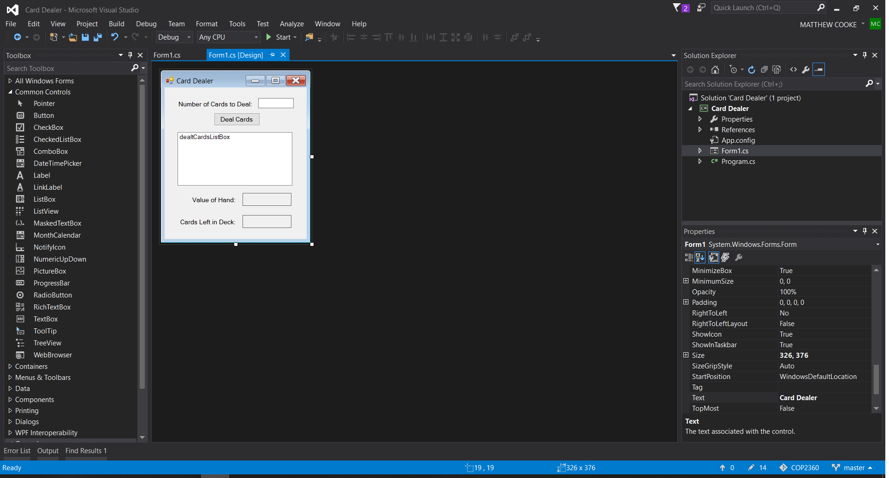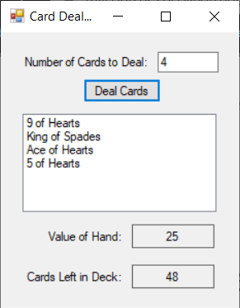using System;

using System.Collections.Generic;

using System.ComponentModel;

using System.Data;

using System.Drawing;

using System.Linq;

using System.Text;

using System.Threading.Tasks;

using System.Windows.Forms;

namespace Card_Dealer

{

public partial class Form1 : Form

{

// Dictionary to simulate a deck of cards

private Dictionary<string, int> deck = new Dictionary<string, int>()

{

// Spades

{"Ace of Spades",1}, {"2 of Spades",2}, {"3 of Spades",3},

{"4 of Spades",4}, {"5 of Spades",5}, {"6 of Spades",6},

{"7 of Spades",7}, {"8 of Spades",8}, {"9 of Spades",9},

{"10 of Spades",10}, {"Jack of Spades",10}, {"Queen of Spades",10},

{"King of Spades", 10},

// Hearts

{"Ace of Hearts",1}, {"2 of Hearts",2}, {"3 of Hearts",3},

{"4 of Hearts",4}, {"5 of Hearts",5}, {"6 of Hearts",6},

{"7 of Hearts",7}, {"8 of Hearts",8}, {"9 of Hearts",9},

{"10 of Hearts",10}, {"Jack of Hearts",10}, {"Queen of Hearts",10},

{"King of Hearts", 10},

// Clubs

{"Ace of Clubs",1}, {"2 of Clubs",2}, {"3 of Clubs",3},

{"4 of Clubs",4}, {"5 of Clubs",5}, {"6 of Clubs",6},

{"7 of Clubs",7}, {"8 of Clubs",8}, {"9 of Clubs",9},

{"10 of Clubs",10}, {"Jack of Clubs",10}, {"Queen of Clubs",10},

{"King of Clubs", 10},

// Diamonds

{"Ace of Diamonds",1}, {"2 of Diamonds",2}, {"3 of Diamonds",3},

{"4 of Diamonds",4}, {"5 of Diamonds",5}, {"6 of Diamonds",6},

{"7 of Diamonds",7}, {"8 of Diamonds",8}, {"9 of Diamonds",9},

{"10 of Diamonds",10}, {"Jack of Diamonds",10}, {"Queen of Diamonds",10},

{"King of Diamonds", 10}

};

public Form1()

{

InitializeComponent();

}

private void Form1_Load(object sender, EventArgs e)

{

//update teh number of cards left in the deck

cardsLeftLabel.Text = deck.Count.ToString();

}

private void dealButton_Click(object sender, EventArgs e)

{

int numCards = 0; //Number of cards to deal

int handValue = 0; //Value of the dealt cards

Random rand = new Random(); //Random number generator

//clear the list box of previous dealt cards

dealtCardsListBox.Items.Clear();

//clear the value of the hand

valueLabel.Text = "";

// get the number of cards to deal

if (int.TryParse(numCardsTextBox.Text, out numCards))

{

//ensure that the number is still within range

if(numCards>0 && numCards <= deck.Count)

{

//deal the cards

for(int count=0; count< numCards; count++)

{

//get the random number

int randNumber = rand.Next(deck.Count);

//get the card at the random position

var card = deck.ElementAt(randNumber);

//show the card

dealtCardsListBox.Items.Add(card.Key);

//Update and display the hand value

handValue += card.Value;

valueLabel.Text = handValue.ToString();

//remove the selected card from the deck

deck.Remove(card.Key);

//update the remaining cards in the deck label

cardsLeftLabel.Text = deck.Count.ToString();

}

}

else

{

//error Message to cover out of range

if(deck.Count == 0)

{

MessageBox.Show("The deck is empty");

}

else

{

MessageBox.Show("Enter a number in the range of " +

"1 through " + deck.Count.ToString());

}

}

}

else

{

//error for non int value

MessageBox.Show("Enter and integer");

}

}

}

}